1. Fully Developed Use Case Description: Chat

Table XX is a fully developed use case description for the use case of chat. The table will further explain the actor, User A / User B that wishes to send a message to one another.

|  |  |
| --- | --- |
| Use Case Name | Chat |
| Scenario | User A have something to tell regarding the date schedule and wish to ask User B. |
| Triggering Event | User A / User B request to send a message |
| Brief Description | Chat room has two different group, the one is for the User A, another is for the  User B. Only the user who is in the group can see the message within. |
| Actors | User A / User B |
| Related Use Cases | Chat |
| Stakeholders | User A / User B |
| Pre-Conditions | User must be already logged in the system. |
| Post Conditions | The message must be able to be seen by the intended user. |

|  |  |
| --- | --- |
| Use Case Name | Chat |
| Flow of Activities | |  |  | | --- | --- | | Actor | System | | 1. Click the chat button | 1. Display the chat box | | 1. Select the user you want to chat | 2. Display the selected group’s message | | 3.1 Input the message into the text field  3.2 Click send button or press the enter key button | 3.1 The system will store the message.  3.2 Display the new message. | |
| Exception Condition | Not connected to the Internet |

**Activity diagram of chat**

**Figure XXX** is an activity diagram of chat. To begin with, the user (User A) will have to click the chat button located on the bottom right corner of each page. Then, the system will respond by displaying the chat box. From there, the user will have to insert his/her chat message and click send. Then the system will store the chat message to the database.

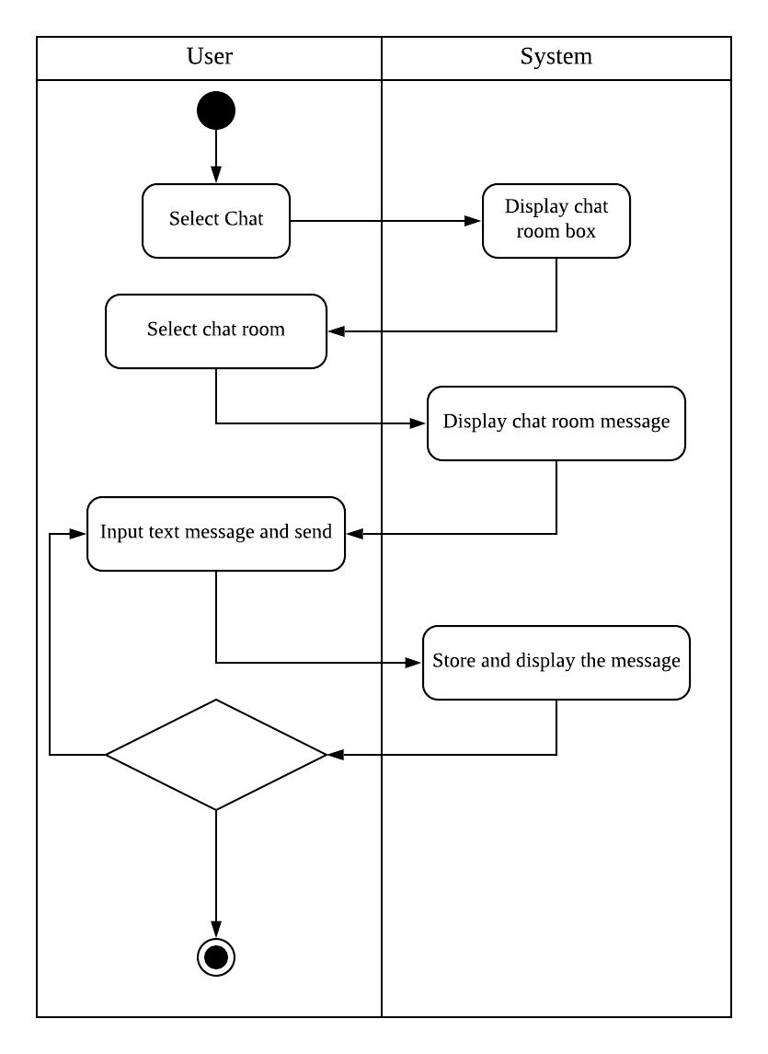

**Figure XXXX : Activity Diagram for Chat**

**Sequence diagram : Chat**

**Figure XXXX** is a sequence diagram of chat. The users in this diagram are User A, User B. The associated class is chat. The diagram shows the sequence of chat that will happen after the user clicked the chat button which is located on the bottom right corner of each page excluding the login page. Then user can choose which group they wish to view/send chat to. After inputting the required chat message and clicking the send button, system will store the chat to the database.

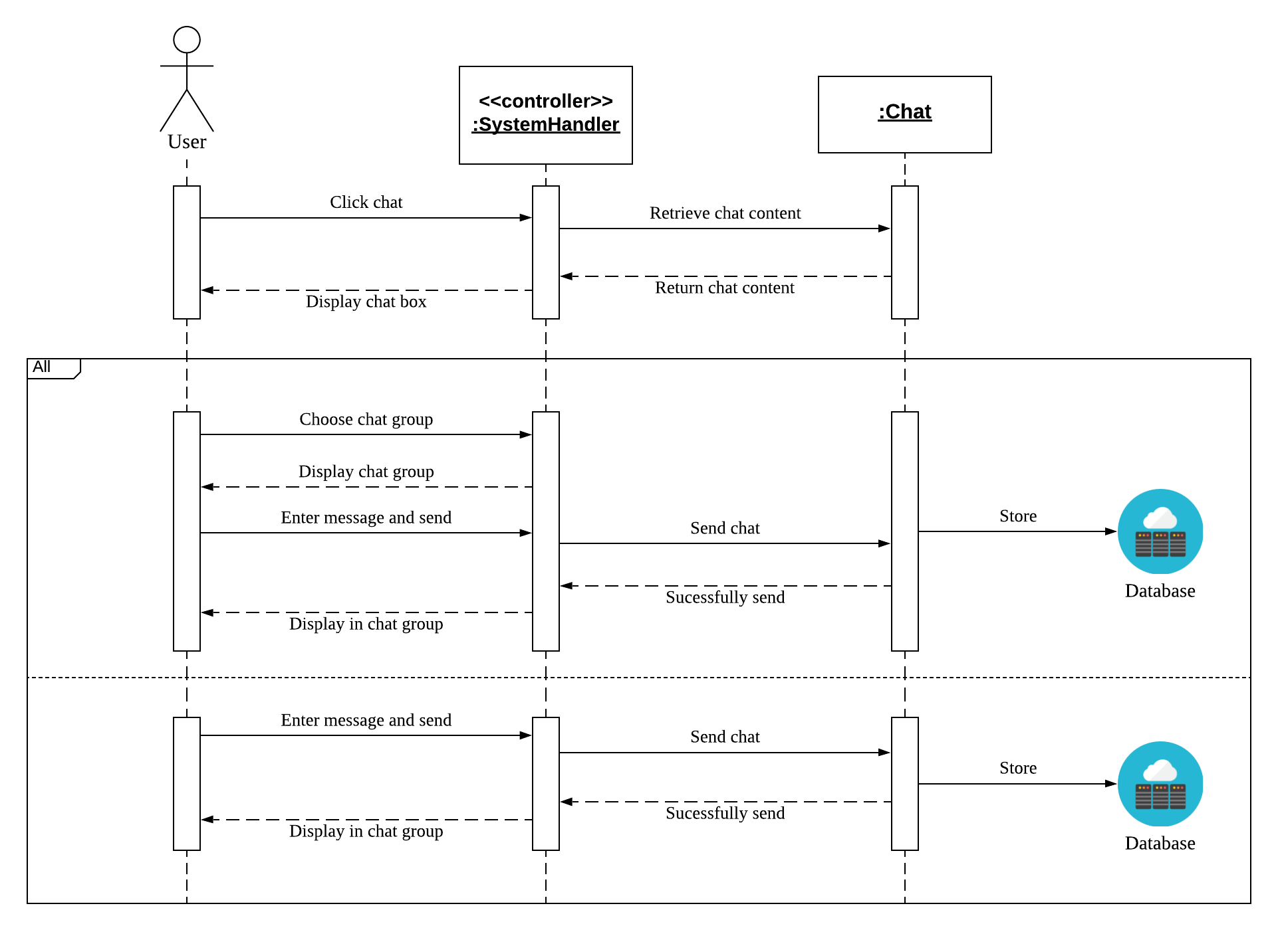

**Figure XXXX: Sequence Diagram for Chat**